

Castle Connect Document Summary V0.1
Business Requirements Document

  - 10/07/2025
  - Version: 0.1

Written by: FNF India

Table of Contents
1. Introduction 4
1.1 Business Context: Castle Connect 4
1.2 GenAI Opportunity 4
1.3 Project Objectives 4
1.4 In Scope 4
1.5 Out of Scope 5
1.6 Key Stakeholders 5
1.7 Prerequisites 5
1.8 Assumptions and Constraints 6
1.9 Risk 6
2. Business Requirements 7
3. Business Architecture 8
3.1 Architecture Diagram 8
3.2 Use Case Diagram 9
3.3 Process Flow Diagram 10
3.2.1 As Is Process flow diagram 10
3.2.2 To be Process flow diagram 11
3.4 Mockups 12
3.4.1 Castle Connect Menu 12
4. Roles and Permissions 12
5. Appendix 13
5.1 Sample Documents 13
5.2 List of Acronyms 13
5.3 References 13

Document Approvals
Date | Version | Approval Name | Organization (Dept.) | Comments
10-07-2025 | 0.1 |  | ADM
Document Change History
Date | Version | Author | Organization (Dept.) | Comments
10-07-2025 | 0.1 | XXXX | ADM | Draft Version

Introduction

Business Context: Castle Connect
Castle Connect (CC) is a web-based title ordering platform developed by Chicago Title Insurance Company, offering a comprehensive suite of services including Title Order Placement, Online Title Examination, Remote Online Notary, Instant document Search, and Earnest Money Deposit for Illinois state and all its counties. Castle Connect also gives users access to recorded documents in any Chicago Metro County - 24/7. Additionally, users can order transfer stamps as well as zoning & water certificates. It caters to a diverse user base including attorneys, paralegals, realtors, and internal staff.

GenAI Opportunity
In Castle Connect (CC) once an order - whether Gold, Classic, Earnest Money, or Direct order is submitted, the current Title Examination process requires attorneys and CC employees to manually review multiple documents such as Prior Title, Property Search, and Name Search, retrieved from TitlePoint for online Title Examination. This manual review is time-consuming and susceptible to human error due to the complexity and volume of information involved.
To address this challenge, the project aims to integrate Generative AI (GenAI) into the Title Examination workflow. By automatically generating document summaries that highlight key information, GenAI will significantly reduce manual effort, improve accuracy, and accelerate the examination process.

Project Objectives
- Automate document summarization using Generative AI for Prior Title, Property Search, Name Search, and Title Search Package documents.
- Reduce manual effort and time spent by CC Employees and Attorneys during the Title Examination process.
- Ensure the GenAI solution provides reliable and contextually accurate summaries of supported documents.
- Integrate GenAI into Castle Connect for all order types (Gold, Classic, Earnest Money, Direct) across all counties in Illinois.
- Enable processing of native and non-native documents (PDFs and TIFFs) using OCR, including handwritten content.

In Scope
The following goals and functionalities are included in the scope of this project:
- Support for all order types: Gold, Classic, Earnest Money, and Direct Orders.
- Document summarization for:
- Prior Title
- Property Exam
- Name Search
- Title Search Package
- Processing of:
- Native PDFs
- Non-Native PDFs
- TIFF files

Out of Scope
- Processing of document formats other than PDF and TIFF (e.g., Word, Excel, JPG).
- Handling of password-protected PDFs.

Key Stakeholders
Stakeholders | Role
ABC

Prerequisites
- Ensure API or backend access to fetch documents from Title Point and integrate with Castle Connect.
- Identify and prepare storage locations for SmartView and Castle Connect summary files.
- Define and configure Admin user roles in Castle Connect for summary access.
- Choose the appropriate Generative AI model and validate its performance on sample documents. (Vision/Text)

Assumptions and Constraints
Assumptions:
- Backend operations team will consistently upload TSP files for non-Gold orders to trigger summary generation.
- TitlePoint will continue to provide reliable access to Prior Title, Property Search, and Name Search documents.
Constraints:
- Only PDF and TIFF formats are supported; other formats (e.g., Word, Excel, JPG) are excluded.
- Summary view in Castle Connect will be available only to Admin users, no access for other users in this phase.

Risk
- OCR misinterpretation of handwritten or scanned documents could lead to inaccurate summaries.

Business Requirements
Requirement ID | Requirement | Priority | Description
BR - 1 | User Login | High | User clicks the Login button to open the login page;
BR - 2 | Document Retrieval | High | System integrates with TitlePoint API to fetch Prior Title,
BR - 3 | Summary Generation Trigger | High | Backend logic monitors Gold Order status and TSP uploads to initiate GenAI summary generation.
BR - 4 | OCR Integration | High | OCR engine extracts text from scanned PDFs and TIFFs, including handwritten content, for GenAI input.
BR - 5 | GenAI Summarization | High | The summary shall follow a defined sequence of fields:  - Property Overview  - Chain of Title & Sales History  - Liens, Mortgages, and Encumbrances  - Covenants, Conditions, and Restrictions (CC&Rs)  - Plat & Survey Information  - Tax and Assessment Details  - Disclaimers & Limitations  - Summary of Key Risks/Considerations  - Recommendations  The generated summary size shall be approximately 15–20KB.
BR - 6 | Summary Storage in SmartView | High | ABC
BR - 7 | Summary Display in Castle Connect | High | Castle Connect UI includes a Summary menu in Title and Closing Documents pages with icons for document and summary popup.
BR - 8 | Admin Access Control | Medium | Castle Connect enforces role-based access control to restrict summary visibility to Admin users only.
BR - 9 | Document Format Support | High | System validates and processes only PDF and TIFF formats; unsupported formats are flagged.
BR - 10 | Popup Summary Interface in CC (TBD) | Medium | UI component displays summary in a modal popup when summary icon is clicked (Business to provide details).

Business Architecture

Architecture Diagram
TBD

Use Case Diagram

Process Flow Diagram

As Is Process flow diagram

To be Process flow diagram

Mockups

Castle Connect Menu
The system shall provide agents with access to a document summary via the designated menu. (Business to provide details)
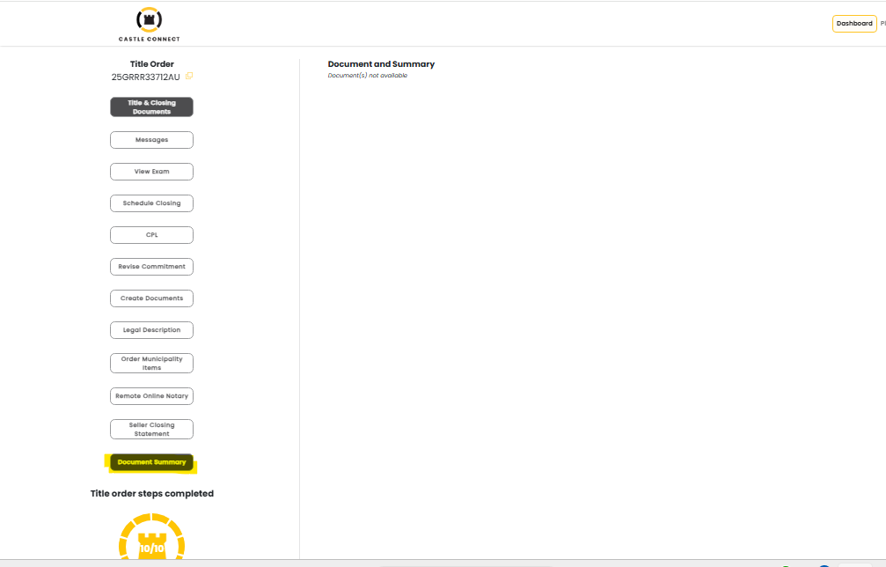
3.3.1_Castle Connect Menu

Roles and Permissions
User Profiles à | Administrator | Title Examination Team (Backend)
Actions
View Document Summary | Enabled in CC Application | Enabled in SmartView System

Appendix

Sample Documents

List of Acronyms
- OCR - Optical Character Recognition
- TIFF -Tag Image File Format
- TSP - Title Search Package

References

